Welcome to Sarlat !

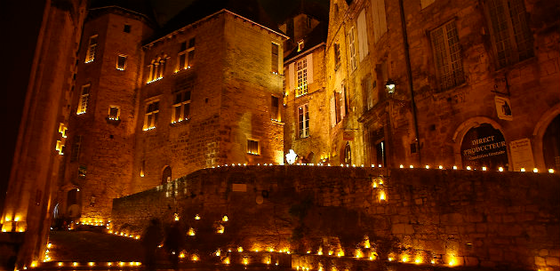

http://blog.sarlat-tourisme.com/visiter-le-perigord-noir-en-nocturne/

The Puymartin Castle is known for the legend of the «Dame Blanche». They say Thérèse de Saint-Clar was imprisoned in the tower of castle. Since, at midnight she haunts the castle. The castle was built at XV century.

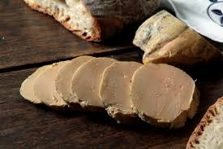

http://www.sarlat-tourisme.com/le-foie-gras
Here you can find serval economic activites as tourism, market (local agriculture), camping, castle visit as Puymartin castle…
The Périgord possesses serval assets as the landscape, the calm, an international airport many connected with England! Their gastronomic specialty are foie gras, truffle, cabécou … Good visit !!

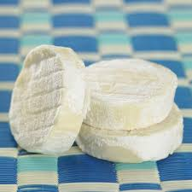
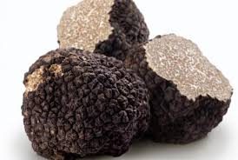

Cabécou (goat truffle
cheese)
https://www.thedailymeal.com/recipes/thomas-kellers-bla
ck-winter-truffle-%E2%80%9Clasagna%E2%80%9D-recipe
/

https://www.culturesforhealth
.com/learn/recipe/cheese-recipes/cabecou

